**Instruction for ScanTool**

**Introduction**

ScanTool is based on a SDK+demo package for Android system, and the project is builded by Android Studio. The directory structure and software hierarchy of the package are shown as below:

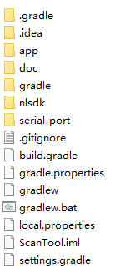 

Directory Structure Software Hierarchy

serial-port and nlsdk are SDK-related source directories, and app is demo-related source directory.

ScanTool app adopts the following third-party development packages:

implementation 'com.jakewharton:butterknife:10.2.1'  
annotationProcessor 'com.jakewharton:butterknife-compiler:10.2.1'  
implementation '[io.reactivex.rxjava2:rxjava:2.0.1](https://github.com/ReactiveX/RxJava/)'  
implementation '[io.reactivex.rxjava2:rxandroid:2.0.1](https://github.com/ReactiveX/RxJava/)'

**Note:**

1. When building the project for the first time, ensure that the host can connect to the Internet. Gradle will automatically update the required third-party tools, and please be patient for updating.
2. Please pay attention to the copyright statement of the third-party library.
3. Applicable products: the device that is suitable for the Easyset is also applicable to this tool.

**SDK Interface**

The procedure is: new device->open the device->operate the device-> close the device (optional).

1. New a stream instance of the communication interface.

The NLDevice constructor parameter is specified as the communication type to be used.

DEV_CDC USB CDC  
 DEV_POS USB POS  
 DEV_COMPOSITE USB HID Keyboard and POS   
 DEV_SUREPOS IBM SurePOS  
 DEV_UART UART

NLDeviceStream ds = new NLDevice(NLDeviceStream.DevClass.*DEV_UART*);

1. Open the stream instance
2. Open the serial port

Access to the serial port requires that the device has root authority to operate the device nodes in the /dev/ directory.

if (!ds.open("/dev/ttyAMA0", 115200, new NLDeviceStream.NLUartListener() {  
 @Override  
 public void actionRecv(byte[] recvBuff, int len) {  
 barcodeLen = len;  
 if (usbOpenChecked) {  
 System.*arraycopy*(recvBuff, 0, barcodeBuff, 0, len);  
 observable.subscribeOn(Schedulers.*newThread*())  
 .observeOn(AndroidSchedulers.*mainThread*())  
 .subscribe(usbRecvObserver);  
 }  
 }  
  
})) {  
 bnOpenDevice.setText(R.string.*TextOpen*);  
 usbOpenChecked = false;  
 return;  
}

The UART device streams have a monitoring port for receiving the data obtained via the UART interface.

interface NLUartListener {  
 void actionRecv(byte [] RecvBuff, int len);  
}

1. Open the USB communication interface (including CDC/ POS/COMPOSITE)

Each time a USB device is plugged in, unplugged, or the interface type is switched, it causes the host to re-enumerate the device (similar to PNP). This action prompts the system to display an authorization window. Clients must apply a system signature to the program. Once the app has a system signature, it will not prompt the user for authorization confirmation when first opened.

if (!ds.open(this, new NLDeviceStream.NLUsbListener() {  
 @Override  
 public void actionUsbPlug(int event) {  
 if (event == 1) {  
 MainActivity.this.ShowToast(getString(R.string.*TextInfoPlugin*));  
 } else {  
 ds.close();  
 MainActivity.this.ShowToast(getString(R.string.*TextInfoPlugout*));  
 observable.subscribeOn(Schedulers.*newThread*())  
 .observeOn(AndroidSchedulers.*mainThread*())  
 .subscribe(usbPlugObserver);  
 }  
 }  
  
 @Override  
 public void actionUsbRecv(byte[] recvBuff, int len) {  
 barcodeLen = len;  
 if (usbOpenChecked) {  
 System.*arraycopy*(recvBuff, 0, barcodeBuff, 0, len);  
 String prefix = String.*format*("scanBarCode len:%s data: ", barcodeLen);  
 String str = new String(barcodeBuff, 0, barcodeLen);  
 runOnUiThread(new Runnable() {  
 @Override  
 public void run() {  
 showText(prefix, str);  
 }  
 });  
 }  
 }  
  
 })) {  
 bnOpenDevice.setText(R.string.*TextOpen*);  
 usbOpenChecked = false;  
 return;  
 }  
 }  
 bnOpenDevice.setText(R.string.*TextClose*);  
 usbOpenChecked = true;  
 setEnable(true);  
}

USB device streams have two monitoring ports.

interface NLUsbListener {  
 /**  
 * Notify the application when the USB device is detected to plug in and out.   
 * @param event 1:USB device plug in 0:USB device plug out   
 */  
 void actionUsbPlug(int event);  
 void actionUsbRecv(byte [] RecvBuff, int len);  
}

actionUsbPlug used to listening USB plug in and out

actionUsbRecv used to listening data receiving

1. Operate the opened device streams
2. Obtain images
3. Obtain the image resolution (when it is called for the first time)

int[] wh = ds.getImgSize();

1. Obtain the image data

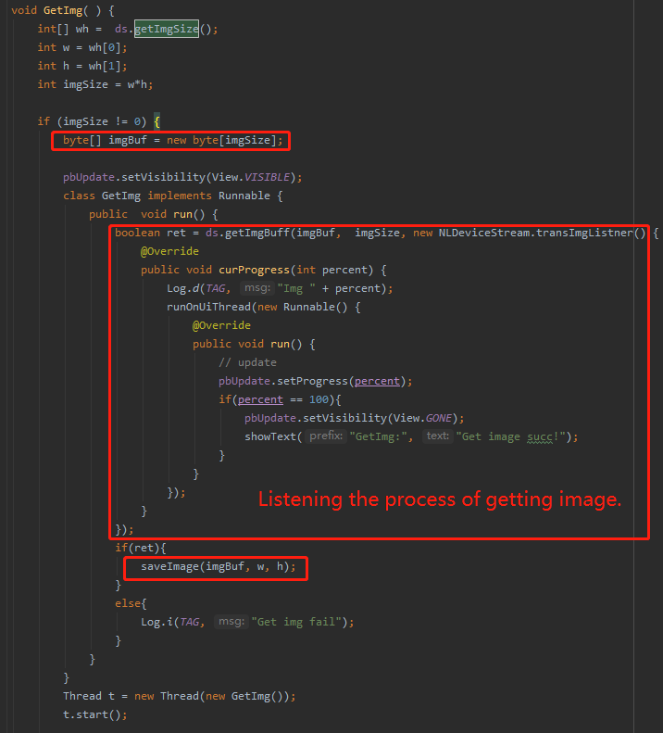

1. Update the firmware

Updating progress is completed by setting monitoring.

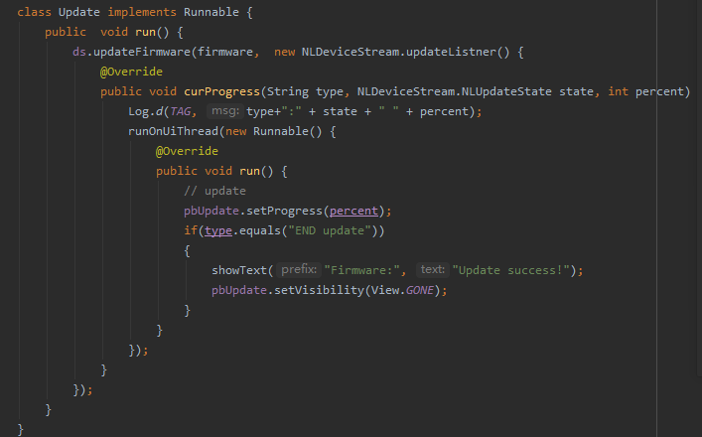

**Note：**

1. For updating the firmware of MCU devices via USB communication, this type of devices will restart into the boot during the firmware updating process, which will cause the android device to detect the USB device plug in and out, and thus requires users to reauthorize USB access. There are two methods to deal with this situation. First, set the system signature to the application integrated with SDK, which can avoid re-requesting authorization after plug in and out. Second, the internal code of SDK adds 2s delay, which requires that the authorization must be confirmed in time when the authorization box pops up.

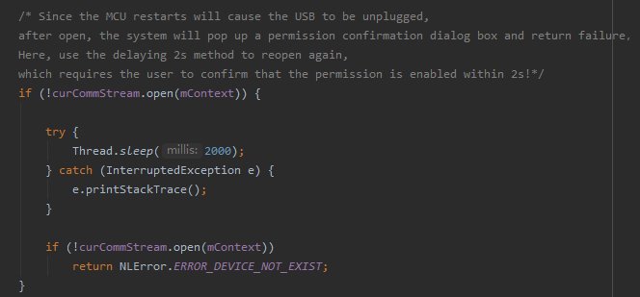

As the code is shown above, for applications that have obtained the system signature, the delay can be reduced to 100ms to improve the updating efficiency.

1. Assure that the device is powered on during the firmware updating process. Confirm that the device has been restarted before powering off the device.
2. Other operations

Omitted.

**SDK Interface**

ScanTool\nlsdk\src\main\java\com\nlscan\nlsdk\NLDeviceStream.java

|  |  |
| --- | --- |
| Enumeration Type | |
| enum DevClass USB Communication Interface | |
| DEV_CDC, | USB CDC |
| DEV_POS, | USB POS |
| DEV_COMPOSITE, | USB HID Keyboard and POS |
| DEV_SUREPOS, | IBM SurePOS (not supported yet) |
| DEV_UART | UART |
| enum NLUpdateState Firmware Updating State | |
| STATE_ENTER_UPDATE, |  |
| STATE_SET_PARAM, |  |
| STATE_SEND_DATA, |  |
| STATE_WAIT_UPDATE, |  |
| STATE_UPDATE_COMPLETE |  |
| Callback Interface | |
| NLUsbListener: Used to listen USB PNP and receiving data when open a USB device. | |
| void actionUsbPlug(int event); | Notify the application when the USB device is detected to be plugged in and out.  1:USB plug in 0:USB plug out |
| void actionUsbRecv(byte [] RecvBuff, int len); | Notify the application when the data is received via the communication interface.  RecvBuff: receiving buffer  Len: buffer size |
| NLUartListener Used to listen receiving data when open a UART device. | |
| void actionRecv(byte [] RecvBuff, int len); | Notify the application when the data is received via the communication interface.  RecvBuff: receiving buffer  Len: buffer size |
| transImgListner: used to listen the progress of image transmission when acquiring images. | |
| void curProgress(int percent); | Percent: transmission progress |
| updateListner: used to listen updating progress when updating firmware. | |
| void curProgress(String type, NLUpdateState state, int percent); | type boot: boot loader kernel: kernel code  flash: other configuration files  state: upgrading status indication, defined in NLUpdateState  Percent: percentage of completion under every state |
| Interface Function | |
| boolean open(Context context, NLUsbListener listener); | When the USB device opens the interface, ensure that it has read and write permission to the USB device node before calling.  **Parameters:**  context: Android context  listener: monitoring USB plug in and out  **Return:**  true: succeed false: failed |
| boolean open(String pathName, int baudrate, NLUartListener listener); | UART device opens the interface  **Parameters:**  pathname: UART device name, such as /dev/ttys0  baudrate: UART baud rate  listener: listen data receiving  **Return:**  true: succeed false: failed |
| NLCommStream getDevObj(); | The application get opened device stream types via the returned stream object.  应用通过返回流对象进行分析打开的设备流类型  **Parameters:**  none  **Return:** stream object |
| String GetSdkVersion(); | Obtain SDK version No.  **Parameters:**  none  **Return:**  SDK version No. |
| void close(); | Turn off the device  **Parameters:**  none  **Return:**  none |
| boolean isOpen(); | Judge whether the device is turned on.  **Parameters:**  none  **Return:**  true: on false: off |
| boolean checkHealth(); | Judge whether the device functions normally (for the specified supported device, please refer to the user guide).  **Parameters:**  none  **Return:**  true: normal false: abnormal |
| String getDeviceInformation(); | Obtain device information  **Parameters:**  none  **Return:**  Response to the command (QRYSYS) sent |
| boolean startScan(); | Send the trigger command (0x10 0x54 0x04) to start reading. And make sure that the serial trigger command (SCNTCE1) is enabled before scanning. It is available in the trigger mode.  **Parameters:**  none  **Return:**  true: succeed in sending the reading command  false: failed to send the command |
| boolean stopScan(); | Stop reading barcodes, available in the trigger mode. Barcode scanning can be stopped if barcode data is not received within the timeout when the device receives the command.  **Parameters:**  none  **Return:**  true: succeed in sending the command  false: failed to send the command |
| boolean restartDevice(); | Restart the device  **Parameters:**  none  **Return:**  true: succeed in sending the command  false: failed to send the command |
| boolean setConfig(String command); | Send a single programming command, like setConfig ("128ENA1 ["), and it won’t be saved when the device is powered off. While the command sent with @, like setConfig ("@128ENA1")](mailto:%22),%20and%20it%20won't%20be%20saved%20when%20the%20device%20is%20powered%20off.%20While%20the%20command%20sent%20with%20@,%20like%20setConfig%20(%22@128ENA1%22)) can be saved after power-off.  **Parameters:**  Command: programming commands based on Unified Commands Set  **Return:**  true: succeed in sending the command  false: failed to send the command |
| String getConfig(String command); | Query the current setting, only available for the single command. For example, send SCNMOD* and respond SCNMOD0.  **Parameters:**  command: query commands  **Return:**  Response to query commands sent |
| int updateFirmware(byte[] fireware, updateListner listner); | Update the firmware of the device, and the firmware upgrading package will contain different contents based on the customer's requirements.  **Parameters**  Fireware: firmware content buffering  Listener: monitor firmware updating progress  **Return:**  Error types described in {class NLError} |
| int updateConfig(File f); | Update device configuration. The configuration file contains multiple configuration contents, and it takes some time to update after the configuration settings are sent.  **Parameters:**  f Batch configuration file handle in xml format  **Return:**  >0: succeed in updating；  <0: failed to update;  =0: succeed in updating and switch the port |
| int[] getImgSize(); | Obtain the size information of the image like length and width.  **Parameters:**  none  **Return:**  Width (int[0]) Height (int[1]) |
| boolean getImgBuff(byte[] ImgBuff, int imgSize, transImgListner listner); | Obtain the image of the device, only available for obtaining images with original size and bmp format.  **Parameters:**  ImgBuff: receive image buffering  imgSize: size of image buffering  **Return:**  true: succeed in obtaining images  false: failed to obtaining images |